Slide 1 | 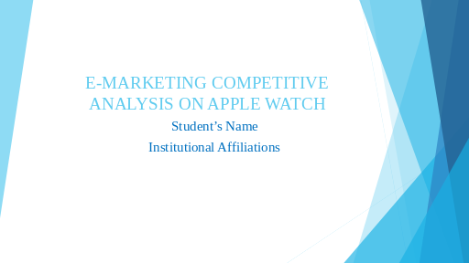
Slide 2 | 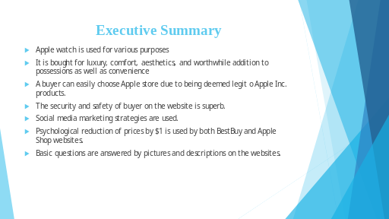
Slide 3 | 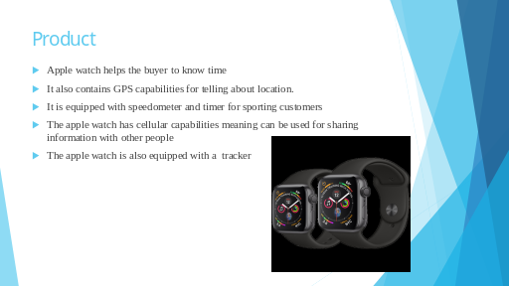
Slide 4 | 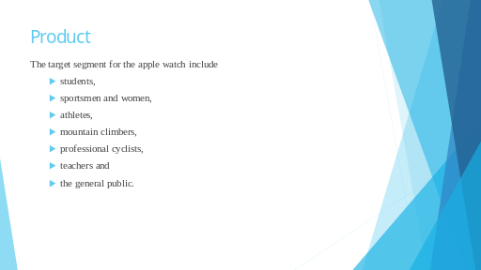 | Apple as a company targets the general public with its products. However, the Apple watch seems to be specifically tailored to serve specific purposes such as helping people to do workouts, plan and schedule exercises, locate or track people as well as combine mobile phone functionalities and offer GPRS services. Therefore, students, athletes, sports persons, mountain climbers and even professional cyclists use apple watches for various purposes (Apple Website, 2019). These forms the target market for Apple company and for marketers and sellers of the Apple watch.
Slide 5 | 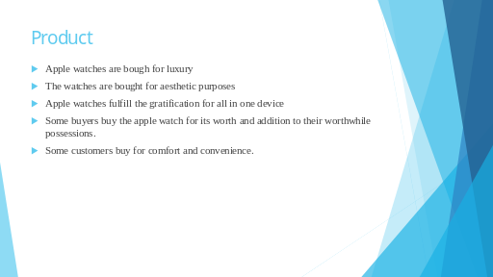 | Apple watches are bought for various reasons. Some of the reasons that lead buyers to buying apple watch is to fulfil the desire for prestige and class that is associated with apple products. Some people buy the Apple watch for aesthetic purposes which act as decorators of their bodies. According to Robson (2019), some buy the watch to add to the worth they have or the possessions that they already have. However, for students and sports persons as well as those who buy the watch for workout, the watch is bought for convenience and security.
Slide 6 | 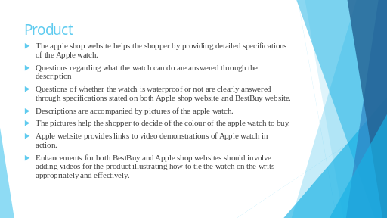 | Bothe BestBuy and Apple Shop websites are designed to assist the user to have an easy time shopping for products. For the case of the apple watch, the two websites provide answers to the most important questions about the price, functionality of the product and the features that the Apple watch has. The descriptions are combined with pictures as well as short videos (for the case of BestBuy) (BestBuy Website, 2019), which are geared towards enhancing the buyer experience on the website. Questions of the waterproof capabilities are given on Apple shop website (Apple Shop Website, 2019).
Slide 7 | 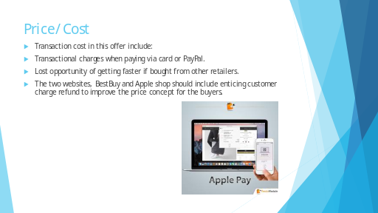 | One of the costs that one incurs while buying any product, whether online or at a physical store is lost opportunity. However, one has to make a choice to buy from one retailer and this means leaving out the others. Therefore, in the case of buying an Apple watch, some of the costs I will incur include charges on top of the price while paying suing my card. A lost opportunity by leaving other e-retailers to choose the Apple shop will also constitute the cost for purchasing the Apple watch. For me, I will choose the Apple shop website for the legitimacy of all the products posted on it, especially products made by Apple Inc.
Slide 8 | 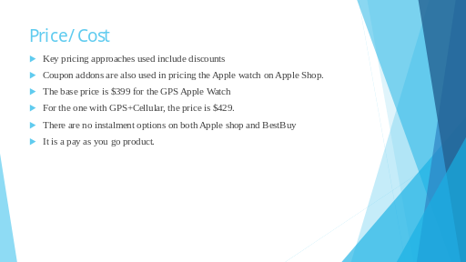
Slide 9 | 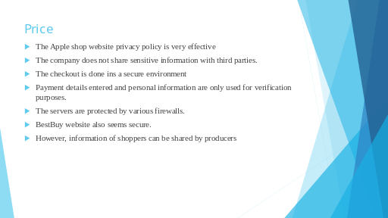 | The safety an security of both BestBuy and Apple shop websites are superb. This is because information shared by customers is protected and only used for verification purposes. The information is also used for identification purposes to ensure products are delivered to the actual people that ordered them. The checkout screens are secured by and safety of data is ensured by ensuring that connections are secure when making e-payments on the websites (Apple Shop Website, 2019; BestBuy, 2019).
Slide 10 | 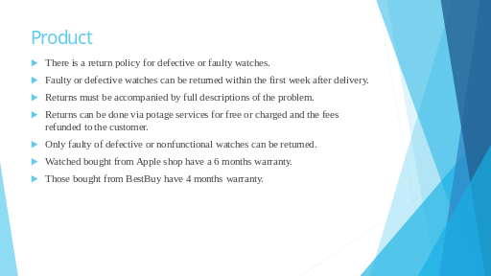 | One of the most important factors in e-marketing and e-retailing is buyer protection and moneyback guarantee. The two websites have return policies within one week and warranties which go up to 12 months. However, for the Apple watch, the Apple shop gives a warranty of 6 months (Brownlee, 2018) while BestBuy gives 4 months warranty (BestBuy, 2019). Faulty watches can be returned within one watch with full explanations identifying the problem of the watch or reason for return.
Slide 11 | 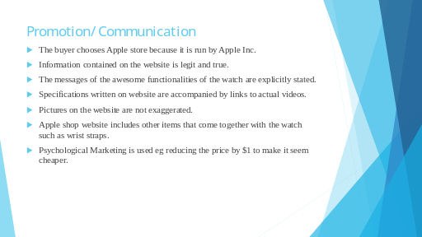 | A buyer is likely to choose Apple shop given that the watch is made by Apple Inc. and therefore, products from an Apple shop are deemed to be perfect and legit than products from other e-retailers such as BestBuy.
Slide 12 | 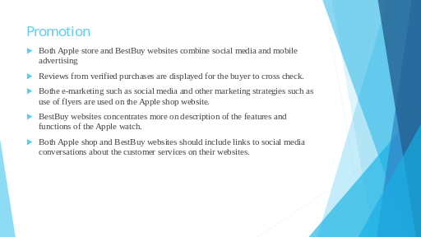 | Social media includes platforms such as Facebook, YouTube, WhatsApp d Instagram among others. Companies sponsor revivers to review and test their products and they can post their test and reviews on platforms such as YouTube for others to see. As such, there exist a lot reviews about the websites and apple watch on platform s such as YouTube and they are meant to attract buyers to the website. Furthermore, there are external weblinks meant o assist shoppers on the two websites.
Slide 13 | 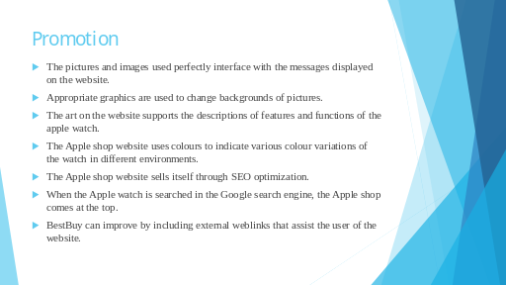
Slide 14 | 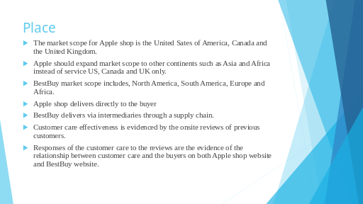
Slide 15 | 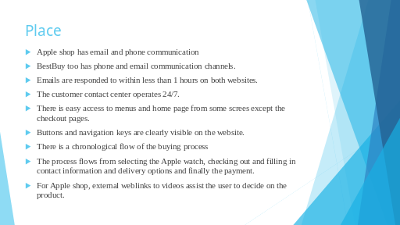
Slide 16 | 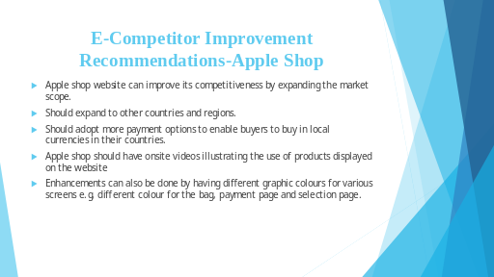
Slide 17 | 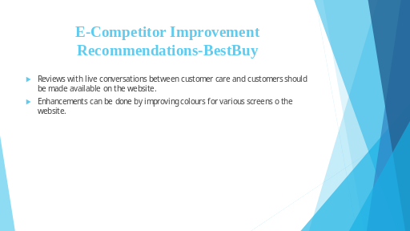
Slide 18 | 